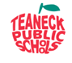
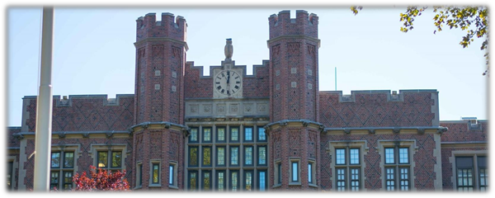
2019-2024

Five – Year Strategic Plan

Stages of Plan Development

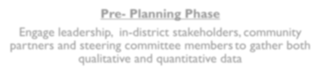

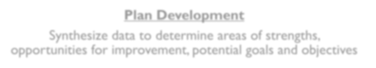


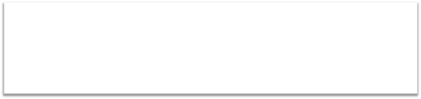
Pre- Planning Phase

Engage leadership, in-district stakeholders,community partners and steering committee membersto gather both qualitative and quantitative data

Plan Development

Synthesize data to determine areas of strengths, opportunities for improvement,potential goals and objectives

Plan and Policy Deployment

Create a strategic plan which includes priority areas,goal statements and objectives
Pre-Planning Phase

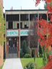

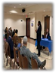

Created a 15 Member Steering Committee which consisted of teachers, parents, community members and one Teaneck High School student

Held four (4) Town Hall meetings, including one at Temple Emeth, a local synagogue, and second meeting at Darul Islah, the community’s local mosque

Created focus group sessions with instructional and educational support professionals at all of our seven (7) schools

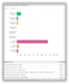
Released the district’s Strategic Plan Survey to the Teaneck Community to increase communication
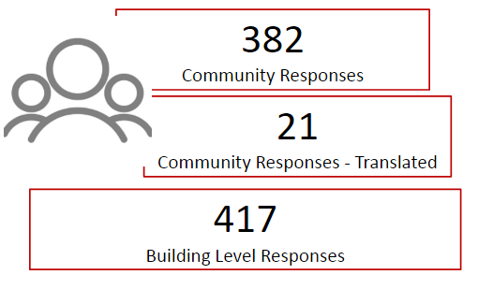
Information Gathered
Key Outcomes by Grade Level

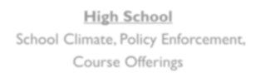
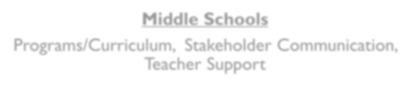

High School

School Climate, Policy Enforcement, Course Offerings

Middle Schools

Programs/Curriculum, Stakeholder Communication, Teacher Support

Elementary Schools Technology and Professional Development
Revising Our Organizational Core


Mission

Teaneck Goals Values Public

Schools

Vision
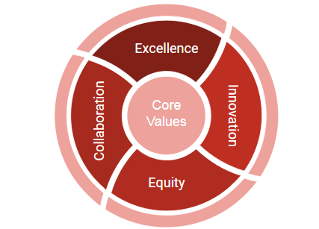
Values: What We Believe
Revised Mission & Vision Statements

Mission Statement:
The Teaneck Public School District educates and empowers students by providing a high-quality, rigorous educational experience which prepares students for success within a diverse, global society.

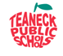
Vision Statement:
The Teaneck Advantage: Educational Excellence for All
Structuring the Strategic Plan

Establish five (5) Priority Areas

Establish one (1) Goal Statement for each Priority Area
Create Three to Four (3 to 4) Attainable Objectives for each Goal Statement




n
y
Priorities and Goals
0102030405 | Academic Program | minguremunitetentio | Goal: Further elevate academic programs by creating varied learning pathways and improving student supports
0102030405 | Facilities & Infrastruct | minguremunitetentio | Goal: Improve facilities and technology in support of 21st Century learning opportunitiesGoal: Execute effective communications andsolidify quality relationships with educational partners within and throughout the community.Goal: Create equitable and inclusive learning opportunities for all studentsGoal: Ensure operational excellence in hiring, developing and retaining all staff members
0102030405 | Communication & Com Partnerships | minguremunitetentio
0102030405 | Equity & InclusionTalent Acquisition & R | minguremunitetentio

Priority Area One (1):Academic Programming

Goal: Further elevate academic programs by creating varied learning pathways and improving student supports.

District:
• Create a system for disaggregating data in support of raising student achievement

High School:
• Create varied pathways of learning (e.g., STEM, the arts, and dual-enrollment opportunities)

Middle Schools:
• Deploy a clear system of support for students experiencing academic challenges • Improve course offerings for academically gifted learners
• Construct theme-based programs to ensure equitable learning experiences

Elementary Schools:
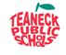
• Deploy a clear system of support for students experiencing academic challenges • Improve course offerings for academically gifted learners

Priority Area Two (2): Facilities and Infrastructure

Goal: Continue to improve facilities and technology in support of 21st Century learning opportunities

• Establish a classroom standard for technology

• Create a protocol for garnering shared input in order to make joint decisions related to technology

• Create failover systems to ensure faster, more reliable, secure network and internet connectivity

• Acquire additional funding for the five-year facilities plan in support of creating new educational spaces (e.g., STEM labs, upgraded science labs, academies, an early childhood center and athletic fields)
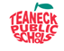

Priority Area Three (3): Communications and Community Partnerships

Goal: Execute effective communications and solidify quality relationships with educational partners within and throughout the community.

• Deploy an internal and external communications plan that engages and strengthens community relations

• Improve operational efficiencies for Central Registration and Community Education programs that results in expanded services aligned to student growth and achievement objectives

• Identify and create additional volunteer opportunities for members of the community to engage with Teaneck Public School students

• Ensure all communications reflect positively on our schools and district, are user-friendly, and include appropriate use of district images and messages in support of the district’s mission, vision, values and goals

Priority Area Four (4): Equity and Inclusion
Goal: Create equitable and inclusive learning opportunities for all students
• Revise processes, procedures, and documentation related to the Intervention and Referral Services committees and other educational support services, as needed• Deploy a revised special education plan that strengthens the district's special education services• Provide translated materials, especially at points of entry (e.g., registration documents and website resources) in languages other than English• Adopt a district wide philosophy for addressing student behaviors in conjunction with the code of conduct• Provide quality equity and bias training to staff members to improve the instructional experience for all students

Priority Area Five (5):Talent Acquisition and Retention

Goal: Ensure operational excellence in hiring, developing and retaining staff
• Improve operational excellence in onboarding and off-boarding practices through the utilization of technology• Provide training sessions for key stakeholders regarding new teacher mentoring which includes feedback from newly hired teachers• Create strategic partnerships with colleges and universities in order to recruit, interview and retain highly qualified instructional staff members• Monitor the effectiveness of the new teacher orientation process

Next Steps

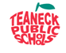
July 2019
• The district’s leadership team will develop detailed, time-specific action plans for actualizing each objective

August 2019
• The Superintendent will approve all action plans and timelines

October 2019
• Action plans and timelines will be shared during the October Board meeting to ensure transparency

The Teaneck Advantage: Educational Excellence for All

